**6. Implement program to apply moving average smoothing for data preparation and time series forecasting.**

**AIM:**

Implement program to apply moving average smoothing for data preparation and time series forecasting.

**PROCEDURE:**

**1.**Import the necessary libraries:

import numpy as np

import pandas as pd

import matplotlib.pyplot as plt

**2.** Load the dataset :

file_path = "/content/autism_screening.csv" *# Update with actual file path*

df = pd.read_csv(file_path)

**3.**Ensure relevant columns exist.

required_columns = {'age', 'class/asd'}

if not required_columns.issubset(df.columns):

raise ValueError(f"Dataset is missing required columns: {required_columns - set(df.columns)}")

**4.** Apply Moving Average Smoothing AND Split into train and test sets (80% train, 20% test)

window_size = 5 *# Adjust window size as needed*

df_agg["Moving_Avg"] = df_agg["class/asd"].rolling(window=window_size, center=True).mean()

split_idx = int(len(df_agg) * 0.8)

train = df_agg.iloc[:split_idx]

test = df_agg.iloc[split_idx:]

**5.** Forecast using Moving Average

forecast = train["Moving_Avg"].iloc[-window_size:].mean()

test["Forecast"] = forecast *# Apply same forecast to all test points*

**6.**Plotting the result:

plt.figure(figsize=(12, 6))

*# Original data*

plt.plot(df_agg["age"], df_agg["class/asd"], marker="o", linestyle="-", alpha=0.6, label="Original Data")

*# Moving Average Smoothed Data*

plt.plot(df_agg["age"], df_agg["Moving_Avg"], color="blue", linewidth=2, label="Moving Average Smoothing")

*# Forecasted values*

plt.plot(test["age"], test["Forecast"], color="red", linestyle="--", linewidth=2, label="Forecast (Moving Avg)")

*# Labels & legend*

plt.xlabel("Age")

plt.ylabel("Mean ASD Score")

plt.title("Moving Average Smoothing & Forecasting")

plt.legend()

plt.grid(True)

*# Show plot*

plt.show()

**OUTPUT**

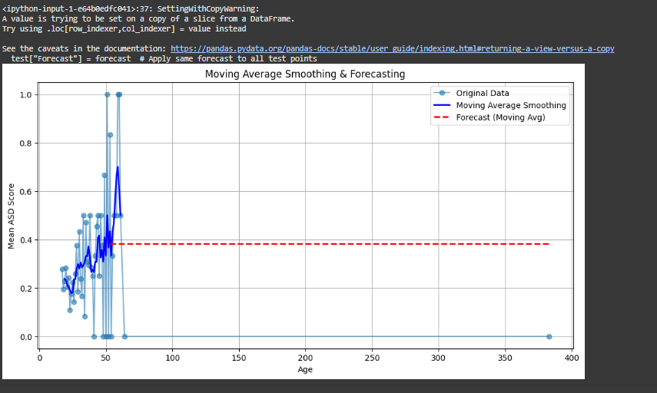

**RESULT:**

The program to implement to apply moving average smoothing on the autism screening dataset has been implemented successfully.